3 Router OSPF Demo
Now all three LANs are working:
PC1 → R1 gateway
PC2 → R2 gateway
PC3 → R3 gateway
Now we can finally test the actual OSPF operation.
Step 1 — Check R1's OSPF neighbor
On R1:
show ip ospf neighbor
We expect R2:
2.2.2.2 FULL/...
Step 2 — Check R2
On R2:
show ip ospf neighbor
We expect two neighbors:
1.1.1.1 FULL/...
3.3.3.3 FULL/...
Step 3 — Check R3
On R3:
show ip ospf neighbor
We expect:
2.2.2.2 FULL/...
If the neighbors are FULL
Then check R1's routing table:
show ip route
You should see OSPF routes similar to:
O 192.168.20.0/24
O 192.168.30.0/24
And on R3:
show ip route
you should see:
O 192.168.10.0/24
O 192.168.20.0/24
Finally — the big test
From PC1:
ping 192.168.30.10
This tests:
PC1
↓
R1
↓
R2
↓
R3
↓
PC3
If that works, you've successfully built a 3-router OSPF network and demonstrated dynamic routing end-to-end.
Router R1,R2,R3 is 2911
Start with R1 → show ip ospf neighbor

Router>show ip interface brief
Interface IP-Address OK? Method Status Protocol
GigabitEthernet0/0 unassigned YES manual up up
GigabitEthernet0/1 192.168.10.1 YES manual up up
GigabitEthernet0/2 unassigned YES unset administratively down down
Vlan1 unassigned YES unset administratively down down
Router>

Router 2

Router>show ip interface brief
Interface IP-Address OK? Method Status Protocol
GigabitEthernet0/0 unassigned YES manual up up
GigabitEthernet0/1 unassigned YES manual up up
GigabitEthernet0/2 192.168.20.1 YES manual up up
Vlan1 unassigned YES unset administratively down down

Router 3

Router>show ip interface brief
Interface IP-Address OK? Method Status Protocol
GigabitEthernet0/0 unassigned YES manual up up
GigabitEthernet0/1 192.168.30.1 YES manual up up
GigabitEthernet0/2 unassigned YES unset administratively down down
Vlan1 unassigned YES unset administratively down down

PC1
IP 192.168.10.10
Subnet mask 255.255.255.0
Gateway 192.168.10.1

PC2
IP 192.168.20.10
Subnet mask 255.255.255.0
Gateway 192.168.20.1

PC3
IP 192.168.30.10
Subnet mask 255.255.255.0
Gateway 192.168.30.1
Router R1

Router>enable
Router#configure terminal
Enter configuration commands, one per line. End with CNTL/Z.
Router(config)#interface gigabitEthernet 0/0
Router(config-if)#ip address 10.0.12.1 255.255.255.252
Router(config-if)#no shutdown
Router(config-if)#exit
Router(config)#interface gigabitEthernet 0/1
Router(config-if)#ip address 192.168.10.1 255.255.255.252
Router(config-if)#no shutdown
Router(config-if)#exit
Router(config)#router ospf 1
Router(config-router)#router-id 1.1.1.1
Router(config-router)#network 10.0.12.0 0.0.0.3 area 0
Router(config-router)#network 192.168.10.0 0.0.0.255 area 0
Router(config-router)#exit
Router(config)#end
Router#
%SYS-5-CONFIG_I: Configured from console by console
Router#show ip interface brief
Interface IP-Address OK? Method Status Protocol
GigabitEthernet0/0 10.0.12.1 YES manual up up
GigabitEthernet0/1 192.168.10.1 YES manual up up
GigabitEthernet0/2 unassigned YES unset administratively down down
Vlan1 unassigned YES unset administratively down down

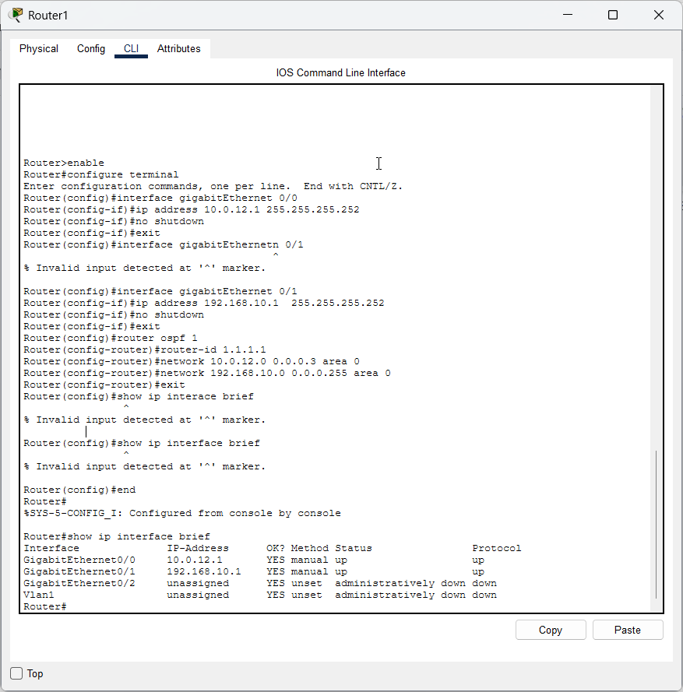
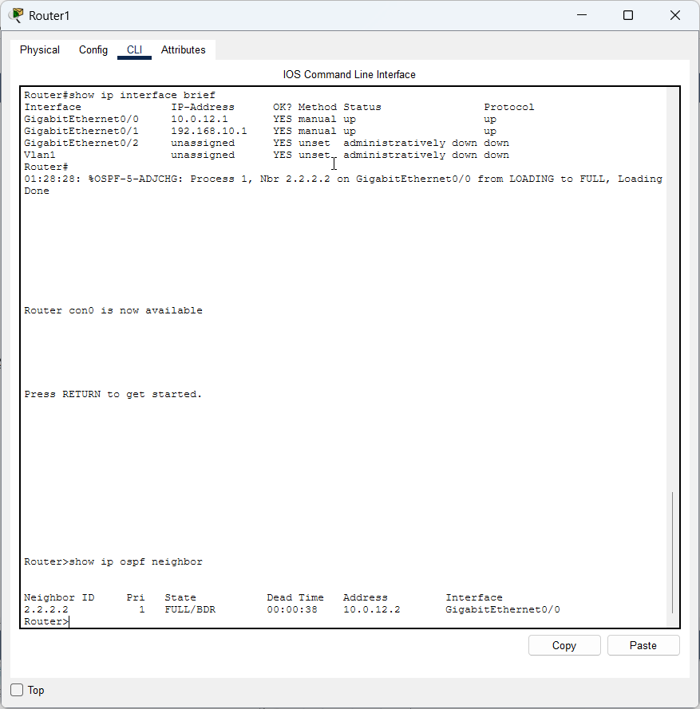

Router 2

enable
configure terminal
interface gigabitEthernet 0/0
ip address 10.0.12.2 255.255.255.252
no shutdown
exit

interface gigabitEthernet 0/1
ip address 10.0.23.1 255.255.255.252
no shutdown
exit

interface gigabitEthernet 0/2
ip address 192.168.20.1 255.255.255.0
no shutdown
exit

router ospf 1
router-id 2.2.2.2
network 10.0.12.0 0.0.0.3 area 0
network 10.0.23.0 0.0.0.3 area 0
network 192.168.20.0 0.0.0.255 area 0
exit

IP Address: 192.168.30.10
Subnet Mask: 255.255.255.0
Default Gateway: 192.168.30.1
So your three LANs become:

Device | LAN IP
R1 G0/1 | 192.168.10.1/24
PC1 | 192.168.10.10/24
R2 G0/2 | 192.168.20.1/24
PC2 | 192.168.20.10/24
R3 G0/1 | 192.168.30.1/24
PC3 | 192.168.30.10/24

2. Now we need to connect R1, R2 and R3
For a straightforward 3-router OSPF practical,
PC1
|
|
R1
|
| 10.0.12.0/30
|
R2
|
| 10.0.23.0/30
|
R3
|
|
PC3
PC2 remains connected to R2.
So the complete topology is:
PC1 PC2 PC3
| | |
| | |
R1 ---------------- R2 ---------------- R3
10.0.12.0/30 10.0.23.0/30
Interface addressing
We'll use:
R1
G0/0 = 10.0.12.1
G0/1 = 192.168.10.1
R2
G0/0 = 10.0.12.2
G0/1 = 10.0.23.1
G0/2 = 192.168.20.1
R3
G0/0 = 10.0.23.2
G0/1 = 192.168.30.1
This gives us:
R1 G0/0 10.0.12.1
|
| 10.0.12.0/30
|
R2 G0/0 10.0.12.2
R2 G0/1 10.0.23.1
|
| 10.0.23.0/30
|
R3 G0/0 10.0.23.2

3. Configure R1
Go to R1:
enable
configure terminal
interface gigabitEthernet 0/0
ip address 10.0.12.1 255.255.255.252
no shutdown
exit
interface gigabitEthernet 0/1
ip address 192.168.10.1 255.255.255.0
no shutdown
exit
router ospf 1
router-id 1.1.1.1
network 10.0.12.0 0.0.0.3 area 0
network 192.168.10.0 0.0.0.255 area 0
exit
Then:
end
show ip interface brief
You should see approximately:
GigabitEthernet0/0 10.0.12.1 up up
GigabitEthernet0/1 192.168.10.1 up up

4. Configure R2
On R2:
enable
configure terminal
interface gigabitEthernet 0/0
ip address 10.0.12.2 255.255.255.252
no shutdown
exit
interface gigabitEthernet 0/1
ip address 10.0.23.1 255.255.255.252
no shutdown
exit
interface gigabitEthernet 0/2
ip address 192.168.20.1 255.255.255.0
no shutdown
exit
router ospf 1
router-id 2.2.2.2
network 10.0.12.0 0.0.0.3 area 0
network 10.0.23.0 0.0.0.3 area 0
network 192.168.20.0 0.0.0.255 area 0
exit
Then:
end
show ip interface brief
You should get:
G0/0 10.0.12.2 up up
G0/1 10.0.23.1 up up
G0/2 192.168.20.1 up up

5. Configure R3
On R3:
enable
configure terminal
interface gigabitEthernet 0/0
ip address 10.0.23.2 255.255.255.252
no shutdown
exit
interface gigabitEthernet 0/1
ip address 192.168.30.1 255.255.255.0
no shutdown
exit
router ospf 1
router-id 3.3.3.3
network 10.0.23.0 0.0.0.3 area 0
network 192.168.30.0 0.0.0.255 area 0
exit
Then:
end
show ip interface brief

6. Now check OSPF neighbors
This is the important part.
On R1:
show ip ospf neighbor
You should eventually see something similar to:
Neighbor ID Pri State Dead Time Address Interface
2.2.2.2 1 FULL/DR 00:00:xx 10.0.12.2 GigabitEthernet0/0
On R2:
show ip ospf neighbor
R2 should see two neighbors:
1.1.1.1
3.3.3.3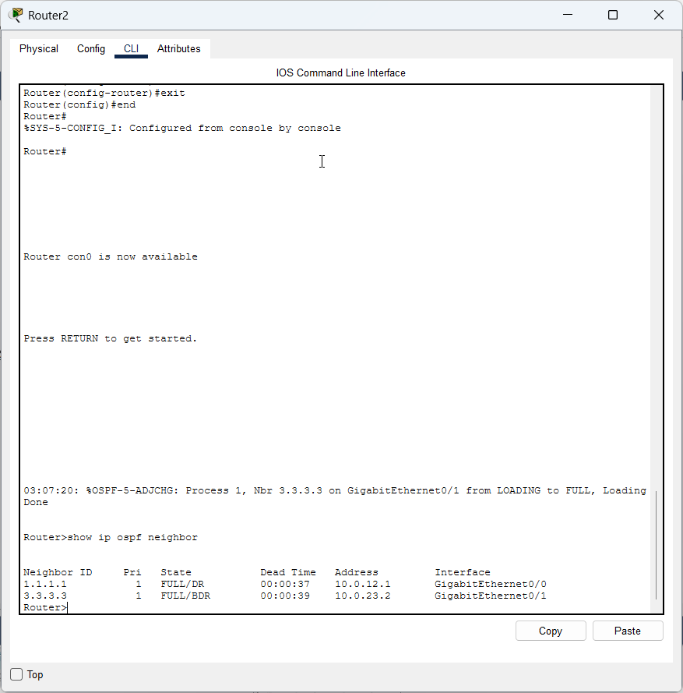
On R3:
show ip ospf neighbor
R3 should see:
2.2.2.2
That's exactly what we expect from the chain topology:
OSPF
R1 <----------> R2 <----------> R3
| | |
LAN 10 LAN 20 LAN 30

7. Then test routing
Once the neighbors are FULL, check:
R1
show ip route
R1 should learn:
O 192.168.20.0/24
O 192.168.30.0/24
R2
show ip route
R2 should learn:
O 192.168.10.0/24
O 192.168.30.0/24
R3
show ip route
R3 should learn:
O 192.168.10.0/24
O 192.168.20.0/24
Then the final demonstration is:
From PC1:
ping 192.168.30.10
You should get replies:
Reply from 192.168.30.10
And you can demonstrate the complete path with:
tracert 192.168.30.10
One important point: don't start troubleshooting show ip ospf neighbor yet. First configure the physical router-to-router links and their IP addresses. Your current G0/0, G0/1, etc. output tells us the LAN interfaces are up, but it doesn't yet establish the OSPF adjacency links.
Debugging switch connections
Your PC1 configuration is correct:
IPv4 Address: 192.168.10.10
Subnet Mask: 255.255.255.0
Default Gateway: 192.168.10.1
So the problem is not PC1's IP configuration.
Since:
PC1 → ping 192.168.10.1 → 100% loss
and R1 also cannot ping 192.168.10.10, the problem is specifically somewhere here:
PC1 ─── Switch0 ─── R1 G0/1
Let's check the switch
Click Switch0 → CLI and run:
enable
show interfaces status
Then run:
show mac address-table
Most important
Also run on R1:
show arp
So we need three outputs:
R1
show arp
Switch0
show interfaces status
show mac address-table

Switch#show mac address-table
Mac Address Table
-------------------------------------------

Vlan Mac Address Type Ports
---- ----------- -------- -----

1 0003.e4ae.e902 DYNAMIC Gig0/1

this output gives us the clue we needed.
The switch has learned only one MAC address:
Vlan Mac Address Type Ports
1 0003.e4ae.e902 DYNAMIC Gig0/1
There is no MAC address currently learned on Fa0/1.
Given your show interfaces status:
Fa0/1 connected
Gi0/1 connected
we need to determine which physical port is connected to PC1 and which is connected to R1.
Run this on Switch0
show cdp neighbors
This should tell us which port connects to R1.
Also run:
show mac address-table dynamic
Then, on R1, run:
show arp
One important observation
Your MAC table showing:
0003.e4ae.e902 Gi0/1
is actually encouraging. It means something on Gi0/1 is actively sending Ethernet frames.
We now need to establish whether:
PC1 ── Gi0/1
R1 ── Fa0/1
or the reverse.
Please send me these two outputs:
Switch0:
show cdp neighbors
R1:
show arp
Router>
Router con0 is now available
Press RETURN to get started.
Router>sh ip int brief
Interface IP-Address OK? Method Status Protocol
GigabitEthernet0/0 10.0.12.1 YES manual up up
GigabitEthernet0/1 192.168.10.1 YES manual up up
GigabitEthernet0/2 unassigned YES unset administratively down down
Vlan1 unassigned YES unset administratively down down
Router>ping 192.168.10.10
Type escape sequence to abort.
Sending 5, 100-byte ICMP Echos to 192.168.10.10, timeout is 2 seconds:
.....
Success rate is 0 percent (0/5)
Router>
Router con0 is now available
Press RETURN to get started.
Router>show arp
Protocol Address Age (min) Hardware Addr Type Interface
Internet 10.0.12.1 - 0003.E4AE.E901 ARPA GigabitEthernet0/0
Internet 10.0.12.2 137 0090.21BE.2601 ARPA GigabitEthernet0/0
Internet 192.168.10.1 - 0003.E4AE.E902 ARPA GigabitEthernet0/1
Router>show ip interface gigabitEthernet 0/1
GigabitEthernet0/1 is up, line protocol is up (connected)
Internet address is 192.168.10.1/30
Broadcast address is 255.255.255.255
Address determined by setup command
MTU is 1500 bytes
Helper address is not set
Directed broadcast forwarding is disabled
Outgoing access list is not set
Inbound access list is not set
Proxy ARP is enabled
Security level is default
Split horizon is enabled
ICMP redirects are always sent
ICMP unreachables are always sent
ICMP mask replies are never sent
IP fast switching is disabled
IP fast switching on the same interface is disabled
IP Flow switching is disabled
IP Fast switching turbo vector
IP multicast fast switching is disabled
IP multicast distributed fast switching is disabled
Router Discovery is disabled
IP output packet accounting is disabled
IP access violation accounting is disabled
TCP/IP header compression is disabled
RTP/IP header compression is disabled
Probe proxy name replies are disabled
Policy routing is disabled
Network address translation is disabled
BGP Policy Mapping is disabled
Input features: MCI Check
WCCP Redirect outbound is disabled
WCCP Redirect inbound is disabled
WCCP Redirect exclude is disabled

Router#show ip interface gigabitEthernet 0/1
GigabitEthernet0/1 is up, line protocol is up (connected)
Internet address is 192.168.10.1/30
Broadcast address is 255.255.255.255
Address determined by setup command
MTU is 1500 bytes
Helper address is not set
Directed broadcast forwarding is disabled
Outgoing access list is not set
Inbound access list is not set
Proxy ARP is enabled
Security level is default
Split horizon is enabled
ICMP redirects are always sent
ICMP unreachables are always sent
ICMP mask replies are never sent
IP fast switching is disabled
IP fast switching on the same interface is disabled
IP Flow switching is disabled
IP Fast switching turbo vector
IP multicast fast switching is disabled
IP multicast distributed fast switching is disabled
Router Discovery is disabled
IP output packet accounting is disabled
IP access violation accounting is disabled
TCP/IP header compression is disabled
RTP/IP header compression is disabled
Probe proxy name replies are disabled
Policy routing is disabled
Network address translation is disabled
BGP Policy Mapping is disabled
Input features: MCI Check
WCCP Redirect outbound is disabled
WCCP Redirect inbound is disabled
WCCP Redirect exclude is disabled

For R1 G0/1
On R1:
enable
configure terminal
interface gigabitEthernet 0/1
ip address 192.168.10.1 255.255.255.0
no shutdown
exit
end
Then verify:
show ip interface brief
And:
show ip interface gigabitEthernet 0/1
You should now see:
Internet address is 192.168.10.1/24
not /30.

Then test PC1
Go back to PC1:
C:\>ping 192.168.10.1
You should now get:
Reply from 192.168.10.1
The first ping in Packet Tracer can occasionally time out while ARP resolves, so if necessary run it again.
Then from R1:
R1# ping 192.168.10.10
That should also work.

Important: check the other LAN interfaces too
This is something we need to be careful about because your original output said /24, but R1's actual configuration is /30.
We should verify R2 G0/2 and R3 G0/1 before proceeding.
Run:
R2
show ip interface gigabitEthernet 0/2
We want:
Internet address is 192.168.20.1/24
R3
show ip interface gigabitEthernet 0/1
We want:
Internet address is 192.168.30.1/24
Your router-to-router links, on the other hand, should remain /30:
R1-R2: 10.0.12.0/30
R2-R3: 10.0.23.0/30
So the addressing should ultimately be:
/30 /30
R1 ---------------- R2 ---------------- R3
| | |
| /24 | /24 | /24
| | |
PC1 PC2 PC3
with:
PC1 192.168.10.10/24 → 192.168.10.1
PC2 192.168.20.10/24 → 192.168.20.1
PC3 192.168.30.10/24 → 192.168.30.1
Fix R1 G0/1 to /24 first and test ping 192.168.10.1 from PC1. This should resolve the first-hop problem.

